

Communicating Salvation by Grace Alone

Man’s Problem
God created man in His own image (Gen 1:27). He formed man of dust from the ground and breathed into his nostrils the breath of life and man became a living being (Gen 2:7)…. Simplified view:
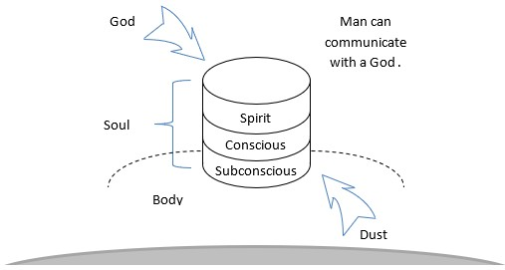
However, man decided to go his own way and disobeyed God. God told man that the consequences of this was death (Gen 2:17). Did Adam die in the Garden of Eden? Yes and no. He did not die physically, at least not immediately. However, the process of physical death did start at that point. He slowly began to die physically. And yet, man did die spiritually. The spirit that God provided to man did die at that moment and man was left without the spiritual support that God originally intended. Man remains in this state to this day. Mankind has been spiritually dead since the “fall”. He will stay in this state until God intervenes again.
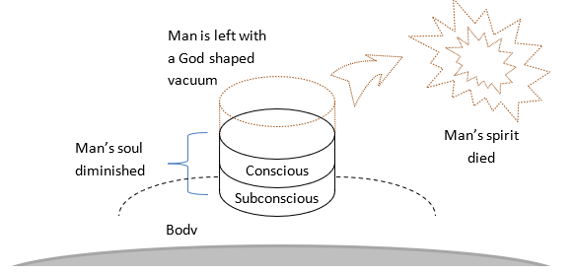
Man is now in a state where he cannot respond to God. His heart has been hardened like flint. He views God as a figment of the imagination. Worshipping God is viewed as total foolishness (1Cor 1:23-24).
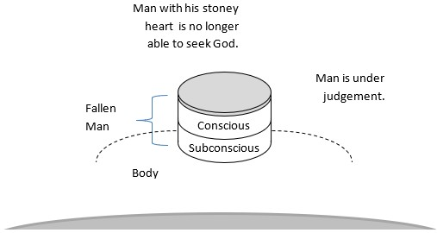
What is life like at this point? It can look like almost anything. Here are some examples:
▪︎ Feeling lost – Luke 7:21, 22, 15:24;
▪︎ Hopeless – Eph 2:12;
▪︎ Alone, Isolated – Isa 59:1-2;
▪︎ Fear – Acts_2:22-24; Heb 2:14, 15;

God’s Solution
God intervened with a merciful plan. He sent His Son Jesus Christ to interpose into man’s situation. While we were still helpless, Jesus came to provide salvation to those who believe (Rom 5:8-9; John 1:12-13). God gives mankind a heart of flesh and a new spirit through the work of Jesus Christ on the cross (Ezek 36:26, 27).
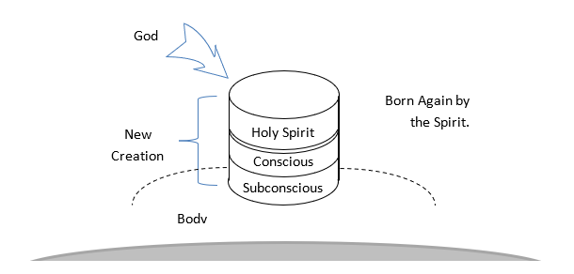
How this happened:
▪︎ Christ Himself bore our sins on the cross – 1Peter 2:24; John 5:24;
▪︎ This fully pays the debt of sin for those who believe – Rom 6:23;
▪︎ God calls us to Himself – John 6:44;
▪︎ He creates in His spiritual children a new heart – 2Cor 5:17;
▪︎ God calls us to be part of His family “in” Christ – Eph 1:13-14;
▪︎ He adopts us into His Family, as His children – Eph 1:5-6;
▪︎ Jesus described this as being “born again” by the Spirit – John 3:3;

grace
(χάρις – Greek) – charis ► noun – graciousness, especially the divine influence upon the heart, and its reflection in the life; including gratitude, — acceptable, benefit, favor, gift, grace(- ious), joy, liberality, pleasure, thankfulness – Titus 3:7; Luke 1:30-31; John 1:14; Rom 3:22-24; Eph 2:8-9;
(χαρίζομαι – Greek) – charizomai ► verb – middle voice of chairó, to grant as a favor, i.e. Gratuitously, in kindness, pardon or rescue — deliver, (frankly) forgive, (freely) give, grant, refers to God freely extending Himself (His favor, grace), reaching (inclining) to people because He is disposed to bless (be near) them. [The Holy Spirit living inside you, in full control is a prerequisite] – Rom 8:32; 1Cor 2:12; Gal 3:18; Phil 1:29; Col 3:13;

hope
(ἐλπίς – Greek) – elpis ► noun – hope, faith, from a primary elpo (to anticipate, usually with pleasure, welcome); expectation (abstractly or concretely) or confidence – Acts 26:6; 1Tim 1:1; Rom 4:18, 8:20-21;
(ἐλπίζω – Greek) – elpizó ► verb – to hope, actively waiting for God’s fulfillment about the faith He has inbirted through the power of His love (cf. Gal 5:6 with Heb 11:1) – Matt 12:21; Rom 8:24-25; 1Cor 13:4, 7, 15:19; 2Cor 1:10; 1Tim 4:10;

Cross References
▪︎ Grace – Eph 2:8-9;
▪︎ Spirit poured out – Ezek 39:29;
▪︎ Faith – Heb 11:1;
▪︎ Hope – Rom 8:24-25;
▪︎ God is reconciling the world to Himself – 2Cor 5:18-19,
▪︎ The church is called to be ambassadors for Christ – 2Cor 5:20;

God’s Role for Christians:
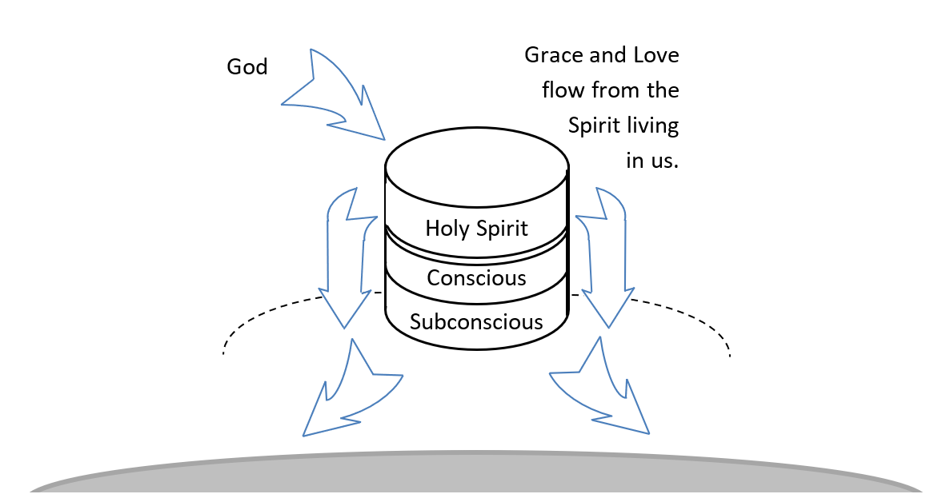

God’s View of the world:

We have no way of knowing what is going on inside another person, but God knows.

Our View of the world:


We really don’t know what is happening inside anyone else.

Detailed View of Man’s Heart:

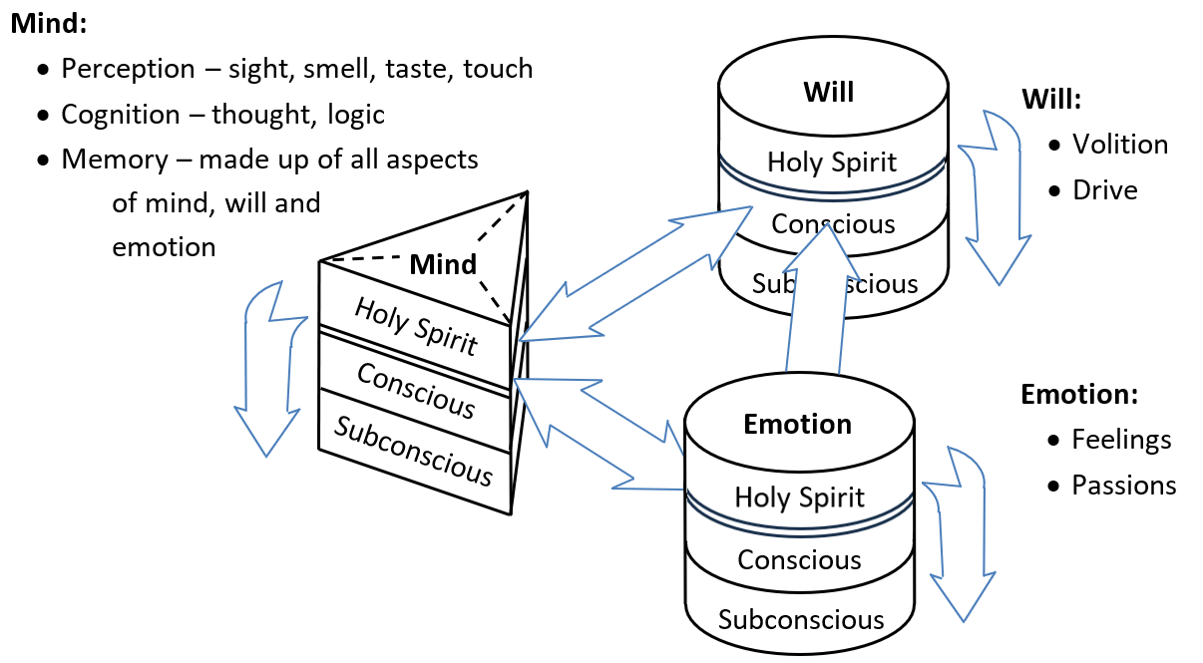
The situation gets more complex the deeper we look at man’s heart.

Discussion Questions
Download questions to Word document (click here). Enter your answers, then meet with some friends to discuss. You can also compare your answers to mine for a virtual discussion… to return… back

1. What was mankind like when he was created?

▪︎
▪︎

2. What is man like at birth?

▪︎
▪︎

3. How did God solve the problem?

▪︎

▪︎

4. How do you respond to friends, relatives, workmates given this situation?

▪︎
▪︎

5. Considering the two views of the world (God’s view and our limited view), what do you say to them on God’s behalf?

▪︎
▪︎

6. Colossians is a good book to study on how sanctification works. This is the process of how God makes His children into faithful representatives for Him. What questions would you would like to answer in a study like that?

▪︎
▪︎

7. Considering the last two references under cross references, 2Cor 5:18-19,
2Cor 5:20; What should be our goal within the church?

▪︎
▪︎

Sources: NASB 1995 Copyright © 1995 by The Lockman Foundation, La Habra, Calif. All rights reserved.
For Permission to Quote Information visit http://www.lockman.org
Bible Hub
© 2025 AndrewKarr.org all rights reserved

