

Colossians 1:1-8 – Paul’s Introduction to Colossians
1Paul, an apostle of Jesus Christ by the will of God, and Timothy our brother, 2To the saints and faithful brethren in Christ who are at Colossae: Grace to you and peace from God our Father.
3We give thanks to God, the Father of our Lord Jesus Christ, praying always for you, 4since we heard of your faith in Christ Jesus and the love which you have for all the saints; 5because of the hope laid up for you in heaven, of which you previously heard in the word of truth, the gospel 6which has come to you, just as in all the world also it is constantly bearing fruit and increasing, even as it has been doing in you also since the day you heard of it and understood the grace of God in truth; 7just as you learned it from Epaphras, our beloved fellow bond-servant, who is a faithful servant of Christ on our behalf, 8and he also informed us of your love in the Spirit.
Interesting Words

will
(θέλημα – Greek) – theléma ► determination, choice, purpose, decree, volition, inclination — desire, pleasure, will – John 5:30, 6:38-39; Rom 12:2;

heard
(ἀκούω – Greek) – akouó ► properly, to hear (listen); (figuratively) to hear God’s voice – Matt 7:24; John 6:45; Eph 1:15; Heb 2:1;

laid up
(ἀπόκειμαι – Greek) – apokeimai ► to be reserved; figuratively, to await, to be appointed, (be) laid up – 2Tim 4:8; Heb 9:27;

constantly
Added by the translators to show the continuous nature of the two present participle- middle voice verbs that follow.

bearing fruit
(καρποφορέω – Greek) – karpophoreó ► to be fertile, to bear, to bring forth fruit, present participle middle – Matt 13:23; Mark 4:28; Rom 7:4; Col 1:10;

increasing
(αὐξάνω – Greek) – auxanó ► a prolonged form of a primary verb; to grow (“wax”), to enlarge (literal or figurative), grow (up), (give the) increase – Matt 6:28; John 3:30; Acts 6:7; 1Cor 3:6-7; 2Cor 9:10;

fellow bond servant
(σύνδουλος – Greek) – sundoulos ► From sun and doulos; a co-slave, i.e. Servitor or ministrant of the same master (human or divine), fellowservant. It expresses the bond of those who serve under the same Master. While doulos already speaks of whole-life ownership, the prefix syn (“with”) adds the dimension of shared identity and mutual accountability – Col 4:7; Matt 24:49-50; Rev 6:11;

Cross References
▪︎ The role of the Holy Spirit in the flow of God’s grace into our lives – 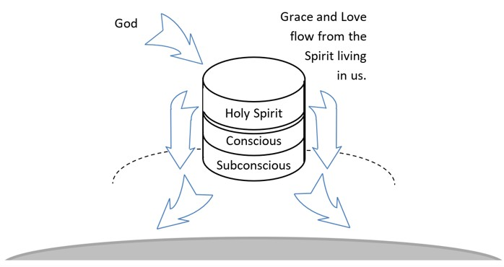
▪︎ Indwelling Spirit – Rom 8:6, 9;
▪︎ Abide in Christ – John 15:1-2, 4, 5;

Discussion Questions
Download questions to Word document (click here). Enter your answers, then meet with some friends to discuss. You can also compare your answers to mine for a virtual discussion… to return… back.

1. What was Paul’s attitude like when he claimed that it was the will of God that caused him to write this letter to the Colossians?

▪︎
▪︎
▪︎

▪︎

2. How does God fulfill Paul’s request for grace and peace in the last part of Col 1:2? Note also the illustration under cross references.

▪︎
▪︎
▪︎

▪︎

3. How did Paul know about the true condition of the Christians in Colossae?

▪︎
▪︎
▪︎

▪︎

4. What phrases or words indicate that these people have truly come into a lasting relationship with Christ?

▪︎
▪︎
▪︎

▪︎

5. What does the concept of “fellow bond servant” bring to your mind as you consider life in the Body of Christ?

▪︎
▪︎
▪︎

▪︎

Sources: NASB 1995 Copyright © 1960, 1962, 1963, 1968, 1971, 1972, 1973, 1975, 1977, 1995 by The Lockman Foundation, La Habra, Calif. All rights reserved. For Permission to Quote Information visit http://www.lockman.org
Bible Hub
© 2024 AndrewKarr.org all rights reserved

