

Colossians 1:9-14 – God’s Transforming Work of Prayer
9For this reason also, since the day we heard of it, we have not ceased to pray for you and to ask that you may be filled with the knowledge of His will in all spiritual wisdom and understanding, 10so that you will walk in a manner worthy of the Lord, to please Him in all respects, bearing fruit in every good work and increasing in the knowledge of God; 11strengthened with all power, according to His glorious might, for the attaining of all steadfastness and patience; joyously 12giving thanks to the Father, who has qualified us to share in the inheritance of the saints in Light.
13For He rescued us from the domain of darkness, and transferred us to the kingdom of His beloved Son, 14in whom we have redemption, the forgiveness of sins.
Interesting Words

pray
(προσεύχομαι – Greek) – proseuchomai ► Verb – Present Participle Middle or Passive (present tense participle = continuous action; middle or passive voice = subject participates in or receives the action) – To pray, pray for, offer prayer, to exchange wishes. From pros (near, from the side) and euchomai; to pray to God, i.e. supplicate, worship – Rom 8:26; Eph 6:18; Phil 1:9; Col 1:3, 4:3; 1Thes 5:16-18; 2Thes 3:1;

filled
(πληρόω – Greek) – pléroó ► to fill completely, cram, level up, to fully supply, satisfy, finish, fill to individual capacity – Rom 15:13, 14; Eph 1:22-23, 3:18-19; Phil 4:19;

knowledge
(ἐπίγνωσις – Greek) – epignósis ► Verb – (from epí, “on, fitting” which intensifies gnṓsis, “knowledge gained through first-hand relationship”) – properly, “contact-knowledge” that is appropriate (“apt, fitting”) to first-hand, experiential knowing – Eph 1:17, 4:13; Col 3:10; 2Tim 2:24-25; 2Peter 1:2-3;

understanding
(σύνεσις – Greek) – sunesis ► noun – from suníēmi, properly, facts joined together for holistic understanding, i.e. synthesized reasoning that joins implicit (indirect) truths for comprehension, for the believer, this “connects the dots”, “synthesized understanding”, through sanctified, inductive reasoning (done under God) – Mark 12:33; Luke 2:47; Eph 3:4; Col 2:2; 2Tim 2:7;

walk
(περιπατέω – Greek) – peripateó ► verb – from peri and pateo; to tread all around, i.e. walk at large (especially as proof of ability); figuratively, to live, deport oneself, follow (as a companion or votary) to go, be occupied with, walk (about) – Rom 6:4; Gal 5:16; Col 2:6;

worthy
(ἀξιός – Greek) – axiós ► adverb – worthily (viewed as “becoming”), suitable because recognized as fitting (having worth that “matches” actual value, from adjective deserving, comparable or suitable, due reward – Rom 16:2; Eph 4:1; Phil 1:27; 1Thes 2:12; 3John 1:6;

please
(ἀρέσκεια – Greek) – areskia ► noun – complaisance, desire to please, the effort to fully and properly please, from verb to be agreeable – used only once in NT, here in Col 1:10… [verb please… Gal 1:10; Rom 8:8; 1Thes 4:1; 1Cor 10:33;]

Cross References
▪︎ The role of the Holy Spirit in prayer –

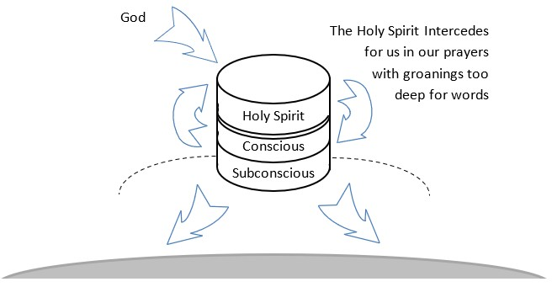
▪︎ Holy Spirit’s Intervention in our prayers – Rom 8:26;
▪︎ Transformed in stages to the likeness of Christ – 2Cor 3:18;
▪︎ God granted repentance – 2Tim 2:24-25;

Discussion Questions
Download questions to Word document (click here). Enter your answers, then meet with some friends to discuss. You can also compare your answers to mine for a virtual discussion… to return… back.

1. Consider and meditate on Paul’s use of the word prayer in Col 1:9 (note the verb tense and voice)… How exactly are we to be praying?

▪︎
▪︎
▪︎

▪︎

2. What was the goal of Paul’s prayer?

▪︎
▪︎
▪︎

▪︎

3. What are the implications of Paul using the word "walk"?

▪︎
▪︎
▪︎

▪︎

4. How does Paul shift his emphasis when he uses the word "worthy" and "please" ?

▪︎
▪︎
▪︎

▪︎

5. How would you prioritize the effects of prayer in last five verses? List them in order of importance.

▪︎
▪︎
▪︎

▪︎

Sources: NASB 1995 Copyright © 1960, 1962, 1963, 1968, 1971, 1972, 1973, 1975, 1977, 1995 by The Lockman Foundation, La Habra, Calif. All rights reserved. For Permission to Quote Information visit http://www.lockman.org
Bible Hub
© 2024 AndrewKarr.org all rights reserved

